Name: Date: Period:
Montezuma II
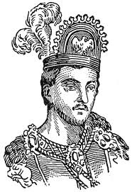

Montezuma II was the ruler of the Aztec people from 1500-1521.
Montezuma II had many great accomplishments including growing the
Aztec Empire over the majority of central and southern Mexico.
Montezuma is most famous for ruling the Aztec people when they
were invaded and conquered by Hernán Cortés, the Spanish
conquistador.

Montezuma conquered many Native American tribes. As a consequence, these tribes had to pay him high taxes. The tribes also had to send people (humans) to be sacrificed to the Aztec gods. These sacrifices were made in the Aztec temples at Tenochtitlan. Montezuma was unpopular with the tribes he conquered because of the taxes and sacrifices he placed on the people. However, Montezuma was popular with his own Aztec people. They considered him a great ruler.

When Cortés and his army arrived in Tenochtitlan, Montezuma was alerted. Some Aztecs believed that Cortés was a god-like being. Montezuma ordered the Aztecs to welcome Cortés to their city and gave him gifts of gold. Cortés took Montezuma hostage, made him a prisoner, and began to rule the city.
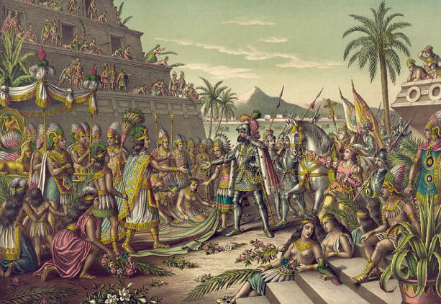
A fight broke out in 1520 between the Cortés’ Spanish troops and the Aztec warriors. The battle grew in size and Montezuma was killed. Aztec and Spanish people mourned the death of Montezuma.

Montezuma II
Directions:
Complete the questions below referring back to the text on the other side of this page.

1. Who was the ruler of the Aztec people when Cortés arrived in Mexico?

A. Atahualpa
B. Cortes
C. Montezuma II
D. Pizarro

2. What did Montezuma give Cortes when they met?

A. gifts of gold
B. a human sacrifice
C. a pyramid
D. a village

3. What was Montezuma’s accomplishment before Cortes arrived?

A. started irrigation for farms
B. expanded the territory in the Aztec Empire
C. built new pyramids in Tenochtitlan
D. offered sacrifices to the Aztec gods

4. What did Montezuma ask for from the tribes he conquered?

A. gifts to give the Spanish conquistadors
B. taxes and irrigation for farms
C. taxes and people for human sacrifices
D. gold for the temples of the Aztec gods

