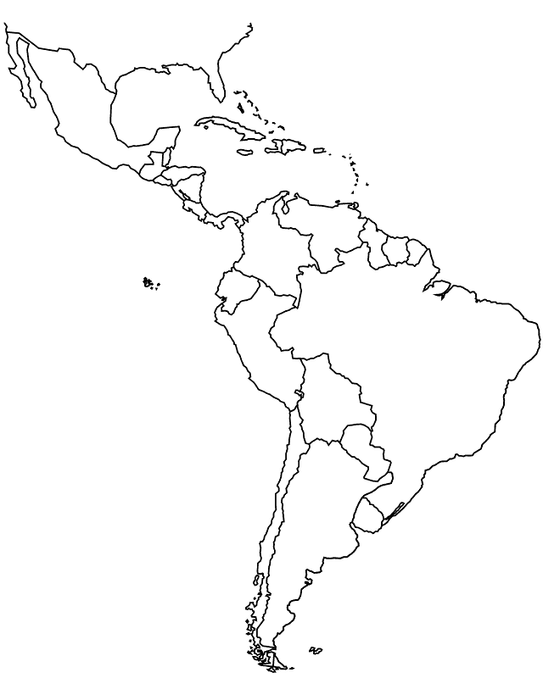
SS6G1: The student will locate selected features of Latin America
A. Locate on a world and regional political-physical map: Amazon River, Caribbean Sea, Gulf of Mexico, Pacific Ocean, Panama Canal, Andes Mountains, Sierra Madre Mountains, and Atacama Desert.
B. Locate on a world and regional political-physical map the countries of Bolivia, Brazil, Colombia, Cuba, Haiti, Mexico, Panama, and Venezuela.

