Name: Date: Period:
Inca Vocabulary

Directions: Match each term from the word bank with the statement that best describes the word. Write the letter that represents the word on the line in front of each statement.

A – Atahualpa B – Quipu C – Cuzco D – Mita
E – Machu Picchu F – Sapa Inca G – Incas H - Quechua
H 1. Language spoken by the Incas – still spoken today in South America.
C 2. Capital city of the Inca civilization.
F 3. Means “Unique Inca” – Title given to the leader of the Inca Emperor.
D 4. Inca form of tax that involves physical labor. All citizens had to work of public projects for one season during the year (building roads, bridges, etc).

B 5. A knotted and colored strings that Incas used to record events in their history. Knots represent numbers and words.

A 6. Sapa Inca during 1520 – 1533 (Ruler of the Incas)
G 7. Advance civilization in Western South America from 1438 - 1533
E 8. Quechua word for “Old Mountain” – retreat for the royal Inca family
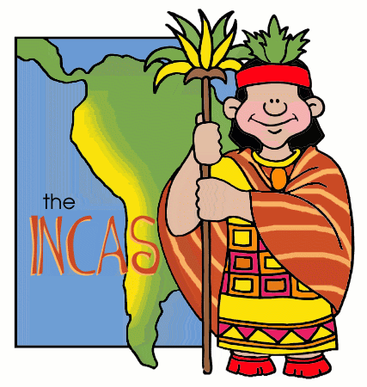
Name: Date: Period:
Inca Internet

Cuzco, Capital City . . .
(http://incas.mrdonn.org/cuzco.html)

Located in Andes Mountains, Heart of the Empire, stone buildings
Always under construction, Temple of Sun in center of city, emperor lived
in Palace, Not many common people lived in city, Protected by fortress

Roads and Bridges . . . (http://incas.mrdonn.org/roads.html)
Connected the empire, common people could not use the roads, roads belong
to government, had to have special permission to use, Army used the roads to protect
Empire, carry supplies to those in need and carry messages between cities, along the roads
you would find storehouses, road signs, and workers. Roads are still used today. Created
suspension bridges, Pontoon bridges and pulley baskets,

Achievements and Inventions . . . (http://incas.mrdonn.org/inventions.html)
Calendar with 12 months (with 3 weeks/10 days per week), Musical Instruments (panpipe and
drums), Quipus (system of measure), Terrace Farming, Freeze dried foods, Use of Gold and Silver,
Stonework, Textiles (clothing, weaving), Aqueducts (baths), Hanging bridges,

Cities, Buildings and Architecture . . . (http://incas.mrdonn.org/architecture.html)
Built well planned cities, Laid out in a grid with central plaza surrounded by public building, temples and houses,
Cities did not have walls around them, separate fortresses built for protection, Cities matched the landscape, master
builders, Building constructed to last and withstand earthquakes, still standing today, outside doors highly decorated
with gold and silver

Terrace Farming . . . (http://incas.mrdonn.org/farming.html)
Great farmers, staples crops included corn, potatoes and quinoa, Incas first to harvest potatoes, also grew tomatoes,
avocados, peppers, strawberries, peanuts, squash, sweet potatoes, beans, pineapple, bananas, spices, and coco. Invented
freeze-dried method for preserving food, Invented terrace gardening/farming, Incas grew more food than they needs and stored this
food to protect the population.

Inca Internet (http://incas.mrdonn.org/index.html):
Use the website with each section to explore the world of the Incas.

