C:\Documents and Settings\chambersma\Local Settings\Temporary Internet Files\Content.IE5\WZE8THKF\MC900015900[1].wmf  
  
Name:

Due Date:

**Freedom Fighter Foldable**

In order to better understand the Freedom Fighters of Latin America and there influences on present day Latin America, your job is to create a foldable. You will be exploring different freedom fighters and their impact on history. You will have 5 days to complete this project. We will begin working on this during class. If you do not complete your classwork, it becomes homework. Below you can find the rubric which shows you all the information that you will need to include on your project!

**List of Freedom Fighters**: Toussaint L’Ouverture, Miguel Hildago, and Simon Bolivar

**Appearance (19 Points)**

|  |  |  |  |
| --- | --- | --- | --- |
| **Points Worth** | **Points Earned** | **Content** | **Is this included?** |
| 10 points |  | The project is in foldable form and is neat (type if handwriting is poor), and organized. |  |
| 5 points |  | The name of the each topic is at the bottom of foldable in bold, large font (print). |  |
| 2 points |  | Name is on the back of the foldable and is legible. |  |
| 3 points |  | Rubric is turned in with project. |  |

**Influences to Latin American Independence (19 Points)**

|  |  |  |  |
| --- | --- | --- | --- |
| **Points Worth** | **Check List** | **Content** | **Points Earned** |
| 1 points |  | Title (Influences to Latin American Independence) is legible, on the front, 1st box moving left to right. |  |
| 4 points |  | Picture of the American Revolution |  |
| 5 points |  | Sentences stating influence of the American Revolution on Latin American independence. (This should be in your own words). |  |
| 4 Points |  | Picture of the French Revolution |  |
| 5 Points |  | Sentence stating influence of the French Revolution on Latin American independence. (This should be in your own words). |  |

**Toussaint L’Ouverture (19 Points)**

|  |  |  |  |
| --- | --- | --- | --- |
| **Points Worth** | **Points Earned** | **Content** | **Is this included?** |
| 2 points |  | Title (Toussaint L’Ouverture) is legible, on the front, bottom section of the 2nd box moving left to right. |  |
| 4 points |  | Picture of Toussaint L’Ouverture (front) |  |
| 4 points |  | Map of the country led to independence (inside top flap) including name of country. |  |
| 9 points |  | Information Section (inside bottom)  Name:  Nickname: (all)  Facts: (4 facts – bullet point) Legible  (typed if necessary) |  |

**Miguel Hildago (19 Points)**

|  |  |  |  |
| --- | --- | --- | --- |
| **Points Worth** | **Points Earned** | **Content** | **Is this included?** |
| 2 points |  | Title (Miguel Hildago) is legible, on the front, bottom section of the 3nd box moving left to right. |  |
| 4 points |  | Picture of Miguel Hildago (front) |  |
| 4 points |  | Map of the country led to independence (inside top flap) including name of country. |  |
| 9 points |  | Information Section (inside bottom)  Name:  Nickname: (all)  Facts: (4 facts – bullet point) Legible  (typed if necessary) |  |

**Simon Bolivar (19 Points)**

|  |  |  |  |
| --- | --- | --- | --- |
| **Points Worth** | **Points Earned** | **Content** | **Is this included?** |
| 2 points |  | Title (Simon Bolivar) is legible, on the front, bottom section of the 4th box on moving left to right. |  |
| 4 points |  | Picture of Simon Bolivar (front) |  |
| 4 points |  | Map of the South America with countries led to independence highlighted (inside top flap). |  |
| 9 points |  | Information Section (inside bottom)  Name:  Nickname: (all)  Facts: (4 facts – bullet point) Legible  (typed if necessary) |  |

|  |
| --- |
| ________ 5 Points - Works Cited is included for all pictures and maps (These websites should be legible (type if necessary) attached on a separate sheet of paper.  **TOTAL POINTS____________________/ 100 points** |

**Box 1 Box 2 Box 3 Box 4**

The American Revolution gave the 13 colonies in America the rights to govern themselves. The Latin American people . . .

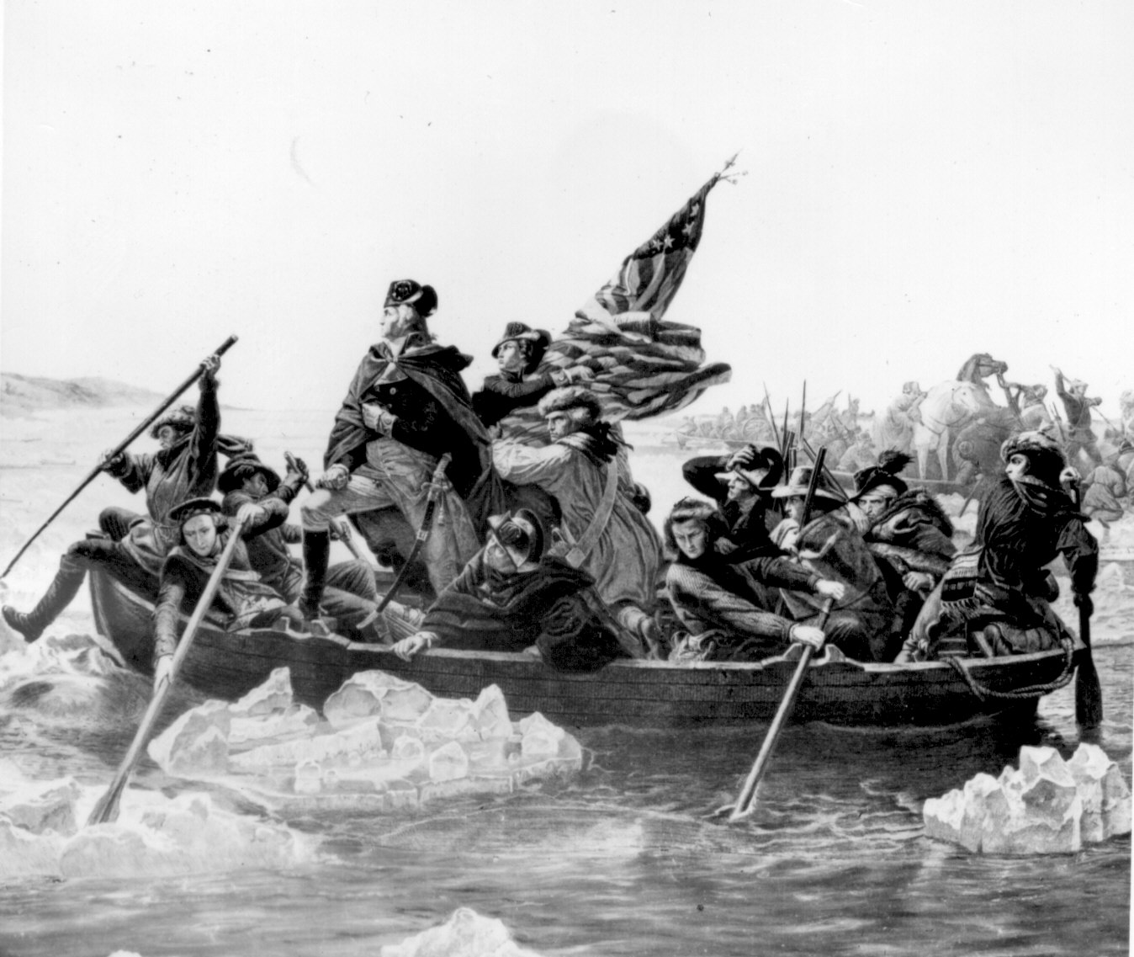

**Toussaint L’Ouverture**

