Name: Date: Period:
The Cold War
Beginning in 1945, the Cold War was a period of distrust and misunderstanding between the Soviet Union and it former allies in the West, particularly the United States. The Soviet Union was a communist country that believed a powerful central government should control the economy as well as the government. This idea was very different from the democracy and capitalism found in the United States. The United States believed that business should be privately owned. After World War II, Soviet dictator Joseph Stalin placed most of the Eastern Europe under communist control. This area was known as the Eastern Bloc. The United States led the Western Bloc countries of Western Europe. The line separating the two was called the “Iron Curtain”.
Another problem of the Cold War was the division of Germany. At the end of the war, the Allies divided Germany into four sections to keep it from regaining power. The United States, Great Britain, France and the Soviet Union each controlled a section. In 1948, the Western Allies wanted to reunite Germany, but the Soviets disagreed. The Soviets declared their section of the country “East Germany”, the reunited sections became West Germany. Even the capital of Berlin in East Germany was divided into East and West. Tensions grew. In 1961, communist leaders build the Berlin Wall. It separated the communist part of the city from the free sections.
Some countries under communist rule tried to break away from the Soviet Union, but the Soviets sent the military into these countries to keep them in line.
Each side in this Cold War thought the other was trying to rule the world. Neither side gave up, and people lived in fear that another world was might erupt. People worried that if such a war happened, it would be a nuclear war. Such a war would be a disaster for everyone on the earth. Countries formed new alliances to protect themselves. In 1949, the western European countries plus the United States and Canada formed the North Atlantic Treaty Organization (NATO). The eastern countries signed the Warsaw Pact.

Which country was the leader of the Eastern Bloc?

Soviet Union

What are the two terms used to describe the dividing line between eastern and western, communist and noncommunist areas?

Iron Curtain

What was one of the disagreements between the Soviet Union and United States during the cold war?

Reuniting Germany

When did the Cold War start?

After the end of WWII – 1945
Name: Date: Period:
GERMANY AFTER WWII

Directions: Label the areas of Germany, Draw a line from each section of Germany to the correct flag.

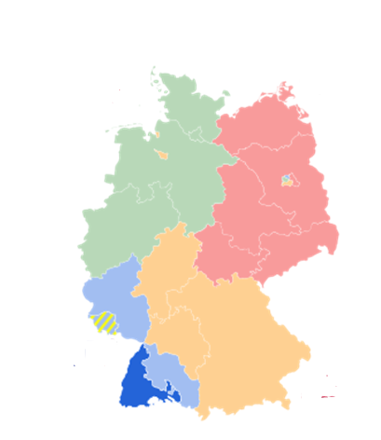
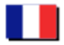 France

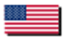United States

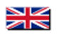Great Britain

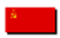USSR

Directions: Draw a line around Berlin were the wall Berlin Wall was constructed.

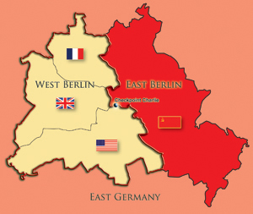

Name: Date: Period:
Rise of the SUPERPOWERS

As the Cold War continued the United States and the Soviet Union increased their area of influence. Most countries allied with each. The United States and the Soviet Union had the ability to influence world events and project worldwide power. The countries were evenly matched. The world took sides, communist or democracy, socialist or free market.
The Soviets had a permanent seat on the UN Security Council. They influenced other communist countries and dictatorships around the world. The Soviets occupied the largest country in the world. The Soviet Union had the third-largest population in the world and the second-largest economy. The Soviets had military and space technology, a worldwide spy network (the KGB) and one of the largest stockpiles of nuclear weapons in the world.
The third-largest county in the world, the United States also had a permanent seat on the UN Security Council and strong ties with Western Europe and Latin America. The fourth most populated country, the United States supported undeveloped countries and developing democratic ones. The United States had powerful military support from NATO, the largest navy in the world, and bases all over the world, even bordering the Warsaw Pact countries. The Central Intelligence Agency (CIA) spent money to spy on the Soviet Union. The United States had a large reserve of nuclear weapons.

What condition is required for a country to be considered a superpower?

Ability to influence world events

Name: Date: Period:
The Collapse of the Soviet Union and German Reunification

The Soviet Union was spending more and more of its money putting down revolts within its country, protecting its borders, and keeping up with the United States in the arms race. By 1985, the economy was so unstable that Mikhail Gorbachev, the head of the Soviet Union, reduced government control of business and increased freedoms for Soviet citizens. These actions helped to improve relations with the United States and inspired people in other Eastern Bloc countries to demand freedom from communist rule.
In November 1989, the Berlin Wall was torn down, and Germany began the process of unifying. People around the world celebrated. East and West Germany were made one country in 1990. The Cold War was over. The Soviet republics that had once been separate countries began seeking their independence too. The Soviet Union was no more. Many countries were created from the former Soviet Union. Russia was the largest.

What marked the end of the Cold War?

East and West Germany reunifying

What was the largest country created from the former Soviet Union?

Russia

