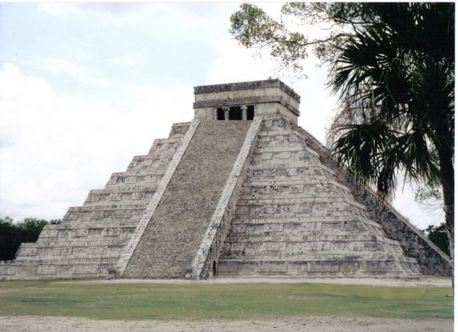
Name: Date: Period:
Mexico’s Great Empire –
The Aztecs
The Aztecs settled in Mexico in the 1200AD. Their capital, Tenochtitlan, was located on the site of present day Mexico City. The Aztecs built temples, public buildings, and houses on an island in the center of Lake Texcoco. They connected the city to the mainland using causeways, or large bridges. The Aztecs developed a hug empire that lasted 300 years.
Much of present day central Mexico was ruled by the Aztecs. They were great warriors and easily took over the communities around them. Each conquered community had to pay tribute, or give goods and money, to the Aztec emperor. In return, the communities received protection from the Aztec ruler. By 1500, more than 5 million Aztecs live in Mexico. With a population of 200,000 people, Tenochtitlan was larger than any European capital.
The Aztec emperor had absolute or complete power. He lived in a beautiful palace, and visitors had to treat him like a god. Solider, government official and priests stood at the top of the Aztec society. Indenture servants and slaves made up the lower classes. Although the Aztecs had class divisions, a person could improve his or her status in society. Showing courage in battle was the best way to better one’s social position.
Because they controlled a large trade network, the Aztecs enjoyed a strong economy. Merchants brought products from faraway places to the market at Tenochtitlan. Many products could be bought at the market, including food, clothes, gold, silver, precious stones, and leather.
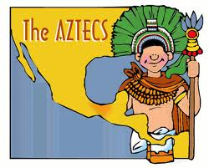
Religion was very important to the Aztecs, and they believed in many gods. Thousands of human sacrifices were made to the sun god. The Aztecs believed that these sacrifices would delay the end of the world. Quetzalcoatl was another Aztec god. The Aztecs thought that Quetzalcoatl had left Mexico. They believed that one day he would come back to bring a time of peace.
In 1519, Spanish conquistadors, or conquerors arrived in Tenochtitlan. The Aztec emperor, Montezuma II, believed the Spanish were representatives of Quetzalcoatl and welcomed them. The Spaniards saw the wealth of the Aztecs and wanted it for themselves. They took Montezuma hostage and looted the city. By 1521, the Spanish had destroyed Tenochtitlan and ended the Aztec Empire.

Mexico’s Great Empire – The Aztecs
Directions: Complete the questions below referring back to the text on the other side of this page.
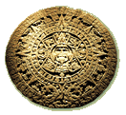
1. The Aztecs live in present day Mexico .
a. Spain
b. Texas
c. Mexico
d. Europe

2. Soldiers, government officials and priests were at the top of Aztec society.
a. Soldiers, government officials and priests
b. Merchants, soldiers and priests
c. Government officials, merchants, and soldiers
d. Indentured servants and slaves

3. Tenochtitlan was built in the middle of a/an lake .
a. desert
b. lake
c. forest
d. ocean

4. Human sacrifices were made to the sun god .
a. Quetzalcoatl
b. the sun god
c. the Spanish
d. the emperor

5. The Aztecs were conquered by Spanish conquistadors .
a. nomadic warriors
b. Mexican soldiers
c. Portuguese explorers
d. Spanish conquistadors

6. Explain why the Aztec Empire ended?
The Aztec Empire ended when the Spanish conquistadors took Montezuma
hostage and looted the city.

